01.Progress
Our Smart Medical Center Management System has achieved significant progress with core functionalities implemented and integrated. The system follows a modern three-tier architecture with React.js frontend, Node.js backend, and MongoDB database.

User Story | Completed  (Yes/ No) | Comment | Member
As a user, I want to register to the system, so I can access the system | Yes | API and UI done. validation & error messages added.
As a user, I want to log in securely, so I can access my account safely | Yes | Node Security auth wired. login UI done.
As a admin, I want to add doctors to frontend, so I can control all doctors. | Yes | UI and Endpoint is implemented
As a admin, I can get a chart of all of the booking appointments. | No | UI implemented and Endpoint is not implemented | Dinsara K.H.S  (IT23588714)
As a user, I want to log my account role-base, so I can access features specific to my role | Yes | API and UI done.
As a user, I want to update my profile, so I can keep my information current | Yes | API and UI done. error messages added.
As a user, I want to logout my account, so I can remove my data if  I no longer use the system | Yes | API and UI done. error messages added.
As an admin, I want to manage staff, so I can control system access | Yes | UI and Endpoint is implemented
As a user, I want password hashing and safe storage, so I can ensure my credentials are protected | Yes | BCrypt  PasswordEncoder configured, user passwords stored as hash
As an admin, I want to view all appointments in the system, so I can monitor and manage appointments. | Yes | UI and Endpoint is implemented | Dinsara K.H.S  (IT23588714)
As an admin, I want to search and filter appointments, so I can quickly find specific appointments. | yes | UI and Endpoint is implemented
As a user, I want to export my appointment data, so I can have a copy of my information | No | UI is done and Endpoint is not implemented

Individual contribution
01.User Management

Task | Status | Note (Implemented parts and not parts)
User Registration | Completed | Implemented registration page with account creation and DB storage
User Login | Completed | Implemented secure login with session/JWT  generation
Role-Based Login | Completed | Implemented role-based redirection and dashboard access
Update Profile | Completed | Implemented profile edit and update functionality

Password Hashing | Completed | Implemented-secure password hashing in  database
Admin View All Appointments in charts | Not Completed | Read the backend and generate line and a bar chart of showing appointments booking all of the time.
Admin View All Appointments | Completed | Implemented admin dashboard listing all  appointments
Admin Search & Filter  appointments | Completed | Implemented search and filter by specialty and status
Export Personal Data | Completed | Export function partially implemented; data export  formats done.

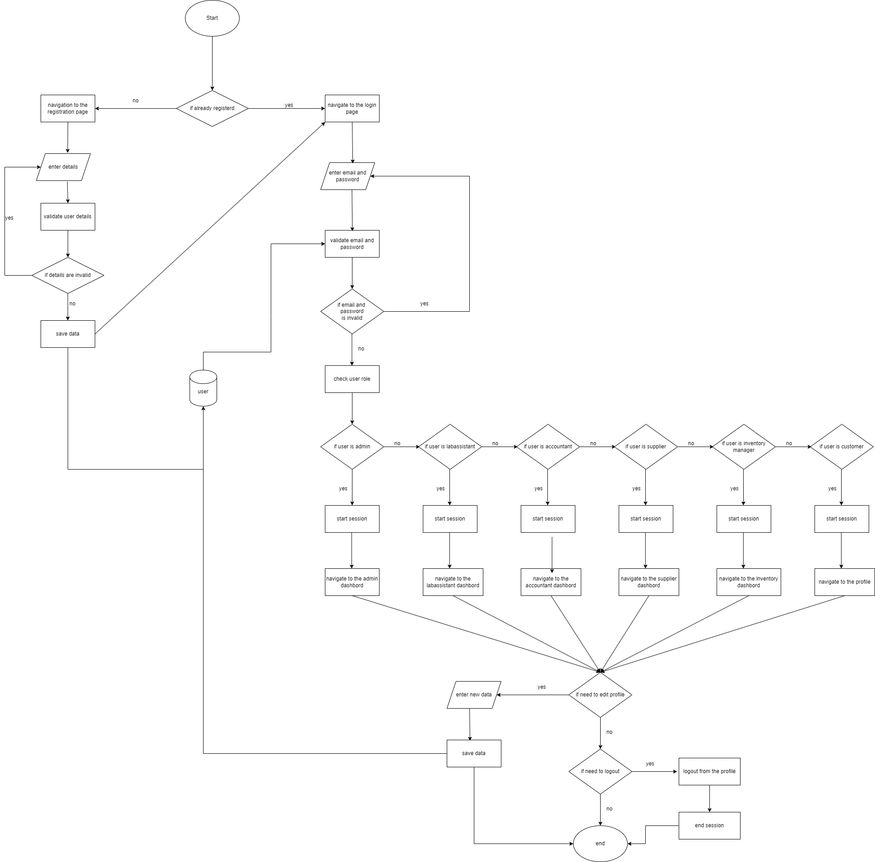

BEGIN
IF user is already registered THEN
NAVIGATE to login page
ENTER email AND password
VALIDATE credentials
IF invalid THEN
DISPLAY error
ELSE
CHECK user role
IF role = Shop Admin THEN
START session
NAVIGATE to Admin Dashboard
ELSE IF role = Accountant THEN
START session
NAVIGATE to Accountant Dashboard
ELSE IF role = Lab assistant THEN
START session
NAVIGATE to Lab assistant Dashboard
ELSE IF role = Supplier THEN
START session
NAVIGATE to Supplier Dashboard
ELSE IF role = Inventory manager THEN
START session
NAVIGATE to Inventory manager Dashbord
ELSE IF role = Customer THEN
START session
NAVIGATE to customer profile
ENDIF
IF need to edit profile THEN
ENTER new data
SAVE data
ELSE IF need to logout THEN
LOGOUT
ENDIF
ENDIF
ENDIF
ELSE
NAVIGATE to registration page
ENTER details
VALIDATE details
IF valid THEN
SAVE data into user
ELSE
DISPLAY error
ENDIF
ENDIF
END

